a. CREATE TABLE contacts (

contact_id NUMBER PRIMARY KEY,

phone_no VARCHAR2(15)

);

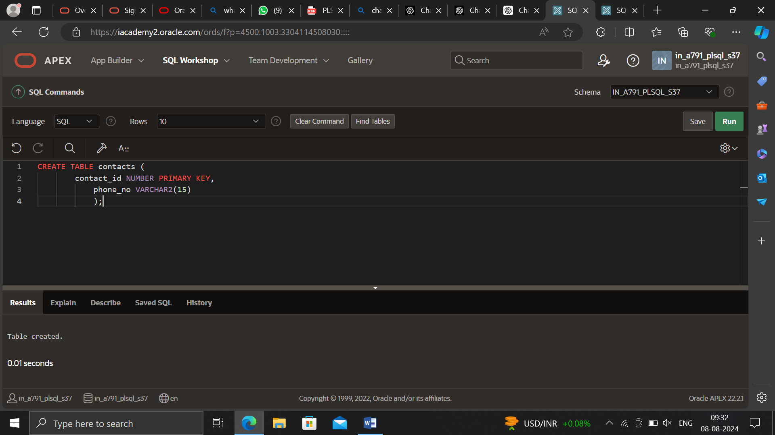

INSERT INTO contacts (contact_id, phone_no) VALUES (1, '1234567890');

INSERT INTO contacts (contact_id, phone_no) VALUES (2, '9876543210');

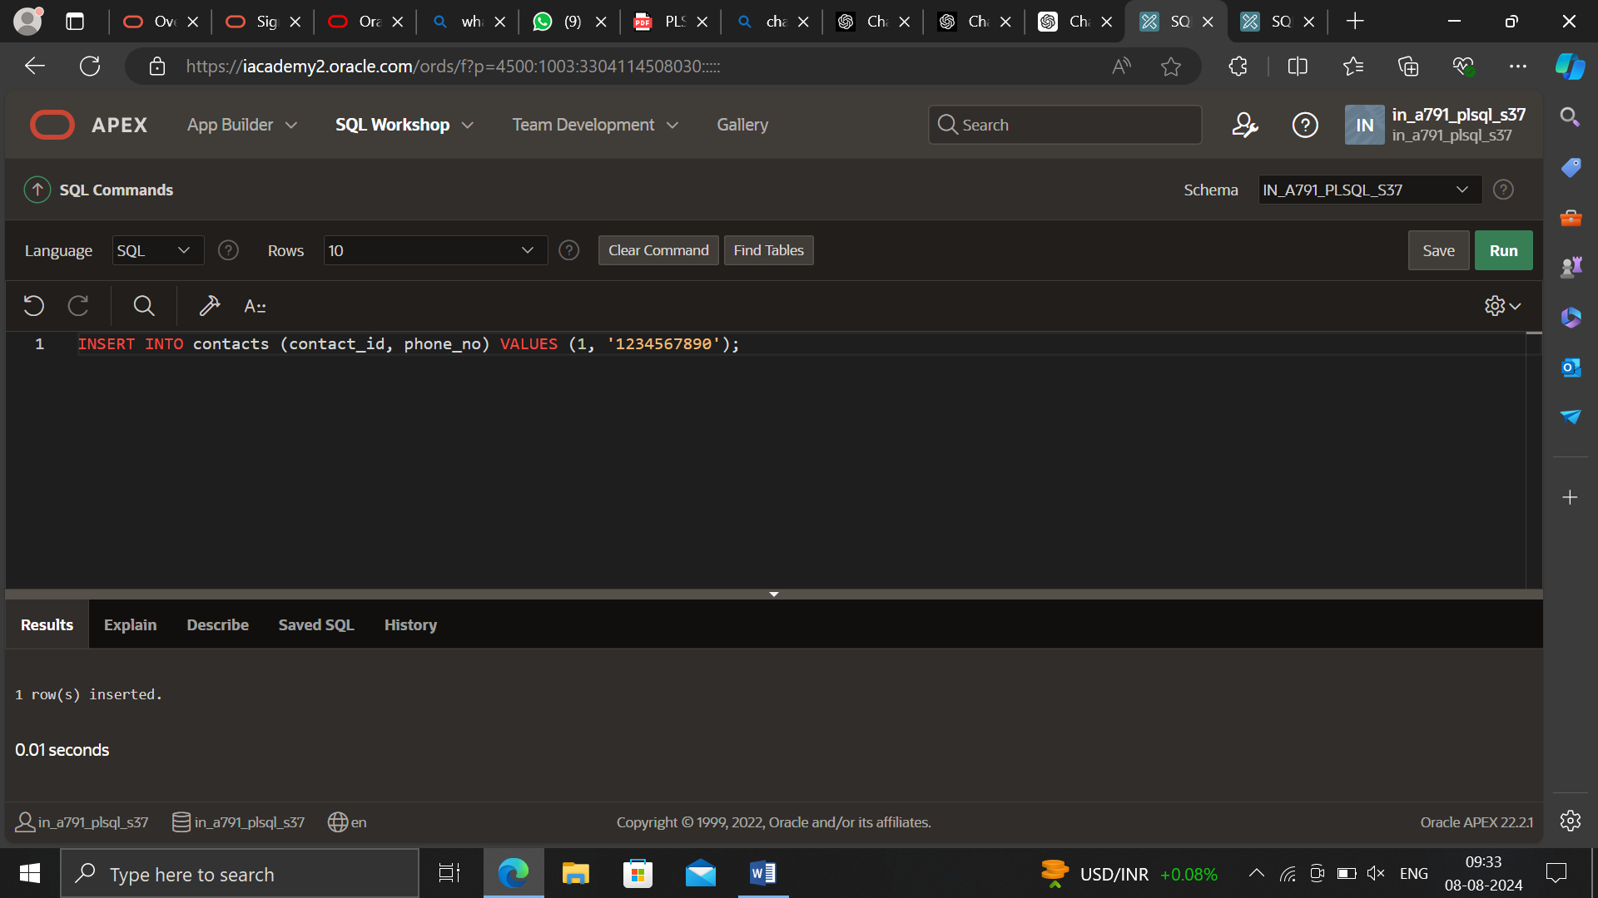

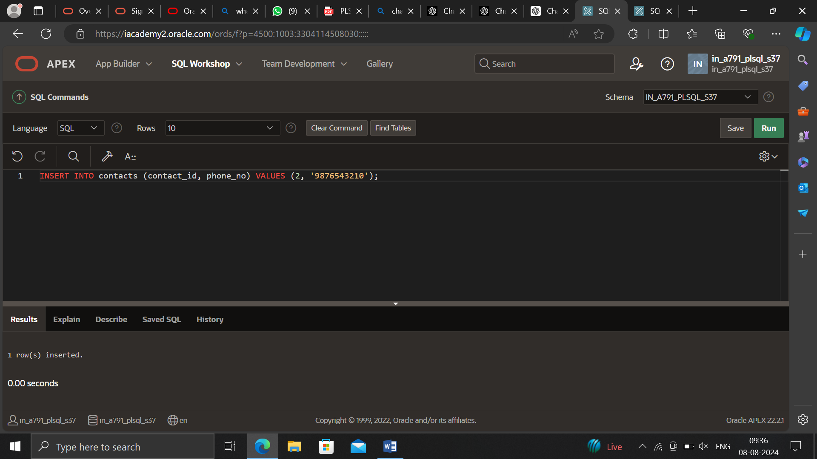

CREATE OR REPLACE PROCEDURE format_phone

(p_phone_no IN OUT VARCHAR2) IS

BEGIN

p_phone_no := '(' || SUBSTR(p_phone_no, 1, 3) ||

')' || SUBSTR(p_phone_no, 4, 3) ||

'-' || SUBSTR(p_phone_no, 7);

END format_phone;

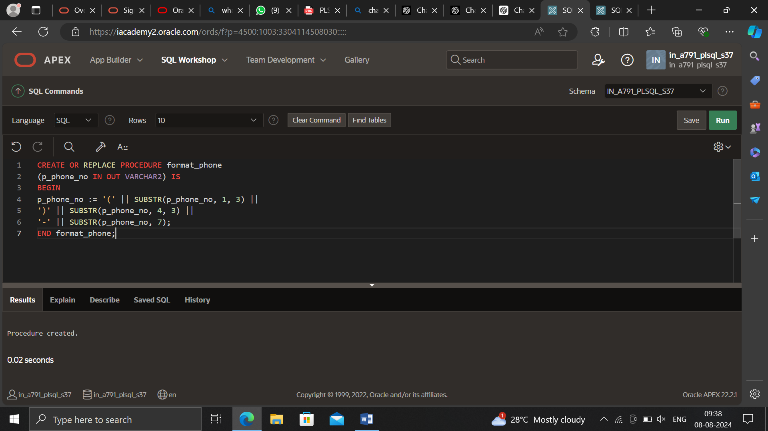

DECLARE l_phone_no VARCHAR2(15); BEGIN FOR rec IN (SELECT contact_id, phone_no FROM contacts) LOOP l_phone_no := rec.phone_no; format_phone(l_phone_no); UPDATE contacts SET phone_no = l_phone_no WHERE contact_id = rec.contact_id; END LOOP; COMMIT; END; /

DECLARE l_phone_no VARCHAR2(15); BEGIN FOR rec IN (SELECT contact_id, phone_no FROM contacts) LOOP l_phone_no := rec.phone_no; format_phone(l_phone_no); UPDATE contacts SET phone_no = l_phone_no WHERE contact_id = rec.contact_id; END LOOP; COMMIT; END; /

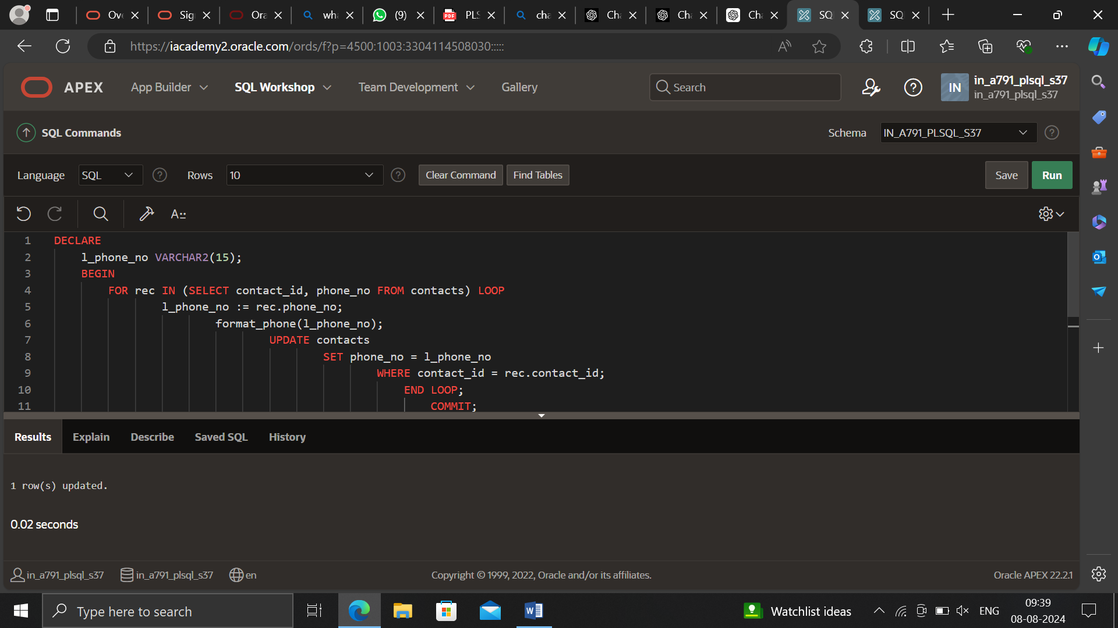

DECLARE

l_phone_no VARCHAR2(15);

BEGIN

FOR rec IN (SELECT contact_id, phone_no FROM contacts) LOOP

l_phone_no := rec.phone_no;

format_phone(l_phone_no);

UPDATE contacts

SET phone_no = l_phone_no

WHERE contact_id = rec.contact_id;

END LOOP;

COMMIT;

END;

/

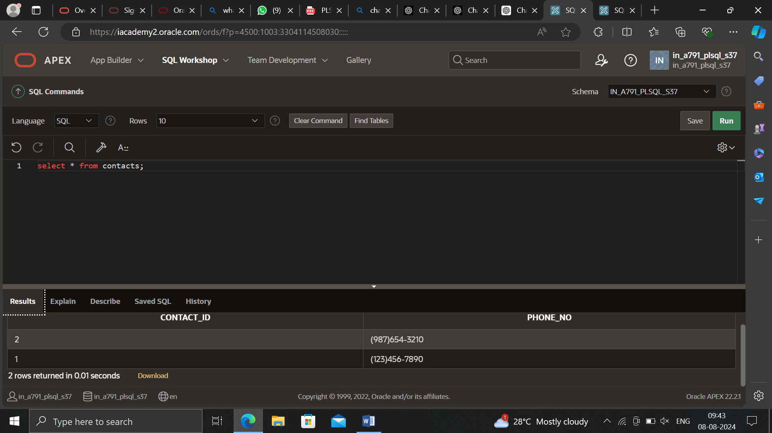

b. CREATE TABLE employees (

employee_id NUMBER PRIMARY KEY,

last_name VARCHAR2(50),

salary NUMBER

);

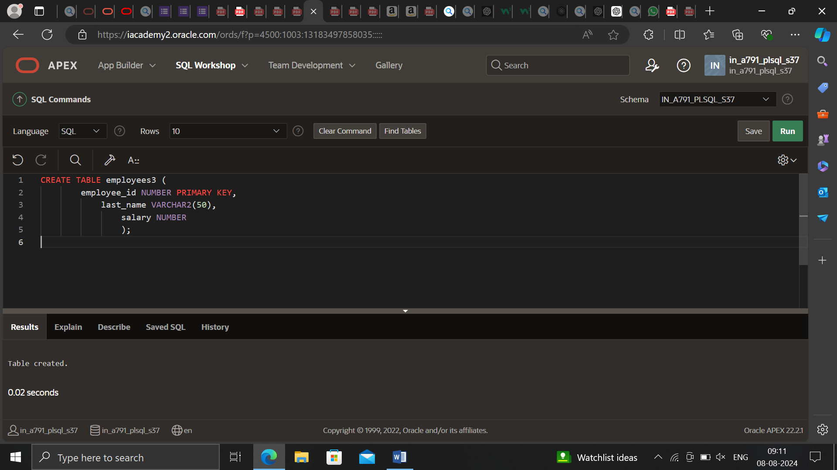

-- Sample data insertion

INSERT INTO employees (employee_id, last_name, salary) VALUES (178, 'Smith', 50000);

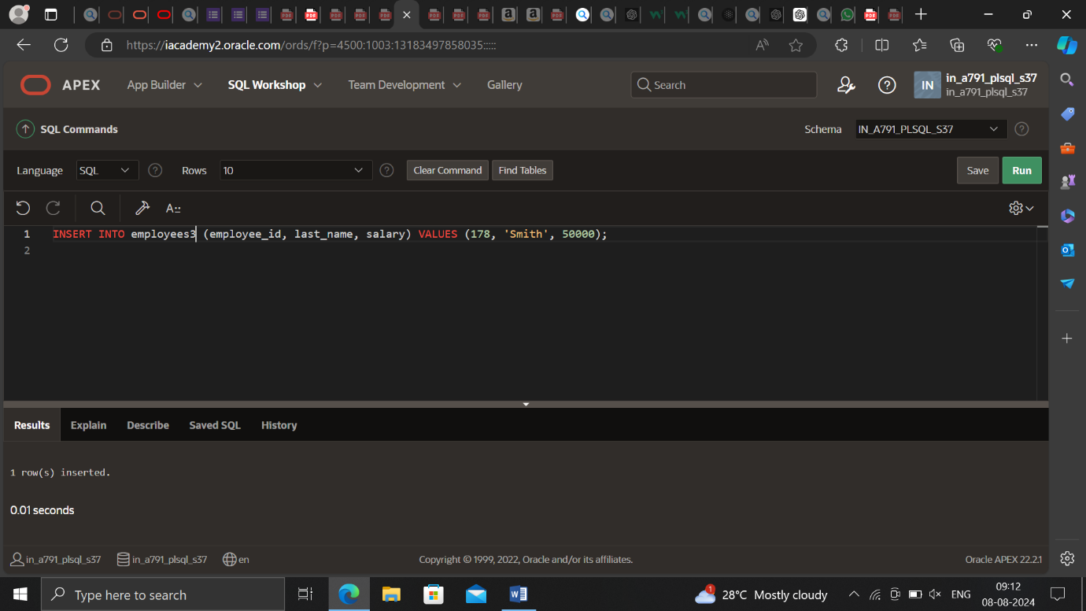

INSERT INTO employees (employee_id, last_name, salary) VALUES (179, 'Johnson', 60000);

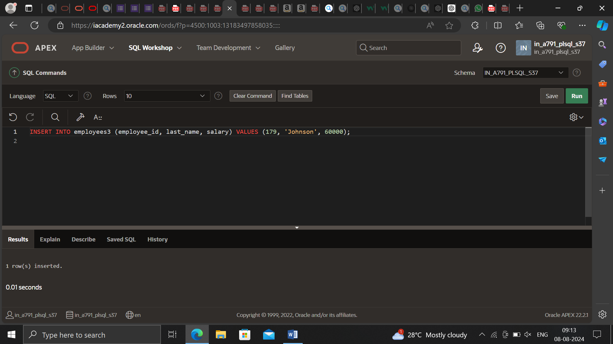

INSERT INTO employees (employee_id, last_name, salary) VALUES (180, 'Williams', 70000);

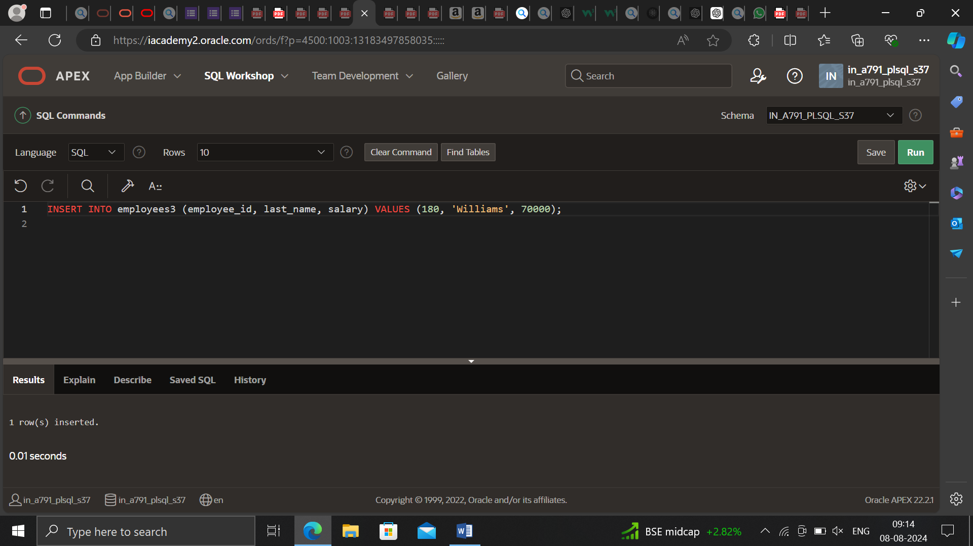

CREATE OR REPLACE PROCEDURE query_emp (

p_emp_id IN employees.employee_id%TYPE,

p_emp_name OUT employees.last_name%TYPE,

p_emp_sal OUT employees.salary%TYPE

) AS

BEGIN

SELECT last_name, salary

INTO p_emp_name, p_emp_sal

FROM employees

WHERE employee_id = p_emp_id;

EXCEPTION

WHEN NO_DATA_FOUND THEN

p_emp_name := 'Not found';

p_emp_sal := 0;

WHEN OTHERS THEN

p_emp_name := 'Error';

p_emp_sal := -1;

END;

/

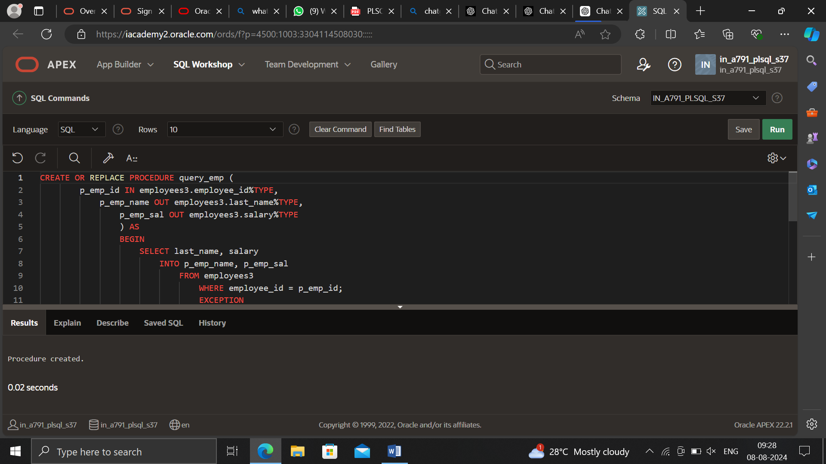

DECLARE

a_emp_name employees.last_name%TYPE;

a_emp_sal employees.salary%TYPE;

BEGIN

query_emp(178, a_emp_name, a_emp_sal);

DBMS_OUTPUT.PUT_LINE('Name: ' || a_emp_name);

DBMS_OUTPUT.PUT_LINE('Salary: ' || a_emp_sal);

END;

